**INTRODUCTION**

The fashion merchandising internship at Permeshwar Fashion Impex was a comprehensive and enriching experience that introduced me to the real-world workings of the garment industry. As an intern, I was given the opportunity to work closely with experienced merchandisers and gain first-hand knowledge of the various stages involved in the apparel production process. From sourcing raw materials and coordinating with suppliers to inspecting samples and preparing documentation, every aspect of the internship provided a valuable learning experience

The internship focused primarily on men's garments, which allowed me to delve into the specific nuances of this segment of the fashion industry. I learned how to prepare and manage lab-dip and desk-loom cards, update tracking sheets, communicate with buyers and suppliers, and understand technical details in tech packs. I also had the opportunity to explore the company’s proprietary software systems for order processing and learned about cost planning and MRP management.

Through a structured and immersive approach, Permeshwar Fashion Impex created a supportive environment for learning and growth. Each week presented new challenges and responsibilities that enhanced my problem-solving abilities, improved my communication skills, and developed my understanding of merchandising as a career path. This report outlines my six-week journey, capturing the tasks I undertook, the skills I developed, and the professional insights I gained throughout the internship.

**Company Overview**



Permeshwar Fashions Impex, established in 1983, is a well-known garment export company with over 40 years of experience in the clothing industry. It designs, makes, and exports high-quality clothing for men, women, and children. With a monthly production of around 600,000 garments, the company earns about US$30 million each year, showing its strong role in the global market. The company is equipped with an internal CAD designing department and advanced digital printing technology, enabling the creation of garments that are not only visually distinctive but also manufactured with superior craftsmanship. These state-of-the-art capabilities ensure a seamless workflow from design conceptualization to final garment production.

The company has its own CAD design team and modern digital printing machines. These tools help create stylish and well-crafted clothes, allowing smooth production from design to final product.

Most of Permeshwar Fashions Impex’s customers are in Europe. This encourages the team to follow the latest global trends. To stay updated, they regularly do market research and take trips to Europe and the U.S. Their goal is to make clothes that match modern Western styles and meet customer needs.

The company always looks for new ideas and follows fashion closely. It uses research and data to design clothes that suit each brand and buyer group.

Permeshwar Fashions Impex aims to become a leading name in garment manufacturing. Its values include honesty, teamwork, and creativity. The company promises top-quality products and services, while caring for people and the planet. It works with focus on safety, quality, and efficiency.

With its global reach, strong technology, and trend-based design, Permeshwar Fashions Impex continues to be a key player in the world of garment exports and fashion.

**WEEK 1**

**(24th April – 30th April)**

My internship at Permeshwar Fashion Impex began with a thorough introduction to the entire merchandising cycle. During the first week, I was primarily focused on understanding how various processes come together to move a garment from the initial concept stage to the final dispatch. This overview was essential because it helped me see the big picture of how the fashion industry operates beyond the design and production stages. The merchandising department acts as a bridge between buyers, suppliers, and the production team, and I was excited to learn how each function contributes to the successful completion of an order.

One of the key learnings during the first week was getting familiar with the merchandising workflow, starting from receiving buyer requirements to delivering finished garments. I was briefed on how the merchandising team interacts with different departments such as design, sampling, production, and logistics. I also learned that the merchandiser must keep close coordination with fabric and trim suppliers, the buying agents, internal sampling teams, and the documentation team to ensure timelines are met and quality is maintained.

My first hands-on task was assisting in the creation of lab-dip cards. Lab-dips are small swatches of dyed fabric that are made to match a specific colour requested by the buyer. These swatches are sent to buyers for approval before bulk dyeing begins. The process was new to me, and I learned how important colour consistency is in fashion production. I observed how the correct shade is achieved through trial and error, and how lighting conditions are considered while matching shades. In some cases, slight variations are accepted, but usually, accuracy is very important, especially for international orders.

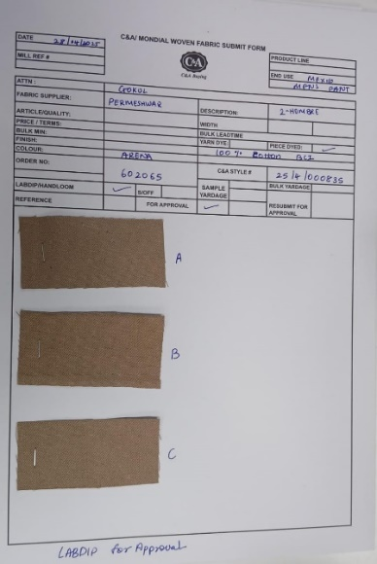

Lab-dip

I also assisted in preparing desk-loom cards, which are sample fabric weaves provided to buyers for approval before actual production begins. These cards help the buyer see how the fabric texture and weave will look in real life. I learned how these desk-looms are developed on handloom machines or small-scale sampling machines, and that even a small difference in the weave can affect the final garment quality. The experience helped me understand how fabric development and approval are critical steps before moving into bulk production.

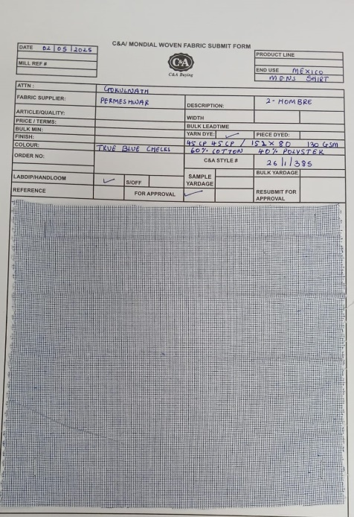

Desk-loom

Another practical activity I was involved in was the preparation of fabric swatch files. These files are collections of fabric samples used for both internal reference and buyer communication. I was asked to cut fabric pieces neatly in A4 size and organize them in folders according to the style, season, or buyer. These swatch files are very helpful during buyer meetings or sampling because they give a physical reference to the textures, finishes, and weight of the fabrics. I noticed that for some styles, multiple swatches were used to test variations in finishes or colour, and these variations had to be clearly labelled and stored for future use.

Through this activity, I also learned about the different types of fabrics the company commonly works with — including cotton, rayon, polyester blends, and embroidered fabrics. My mentor explained the difference between greige fabric (raw, unprocessed fabric) and finished fabric (dyed or printed). I also got a basic idea of fabric construction, such as the difference between woven and knitted materials, and how the fabric structure affects garment fall and drape. All these things were already cleared to me during my college days, so it was easy to understand everything.

During my interactions with the sampling department, I got a glimpse into how samples are planned based on buyer inputs. I understood that even though designers come up with the basic concept, the merchandising team plays a major role in turning that concept into a physical sample by coordinating all resources. I also noticed that attention to detail is very important in merchandising work, especially when it comes to labelling swatches, shade cards, and samples correctly.

In addition to the technical tasks, I was introduced to the company's filing system. There were dedicated folders and digital records for each buyer and style, and everything had to be updated regularly. I learned how physical samples, swatch cards, and shade cards were stored systematically to avoid any confusion. This helped me understand how critical organization and record-keeping are in the merchandising field. Any misplacement or wrong labelling could cause delays or rework.

Another thing I noticed was how important communication is for a merchandiser. Even in the first week, I observed my seniors frequently communicating with buyers over email, clarifying fabric quality, colours, and delivery timelines. The emails had to be very clear and professional, and often included attachments like lab-dip images or fabric swatch photos. I realized that while technical knowledge is important, being able to explain and communicate that knowledge clearly is just as essential.

As part of the orientation, I also attended a brief session where the team explained the critical path or T&A calendar (Time and Action calendar). This calendar outlines the major activities, deadlines, and approvals that need to happen from the beginning of an order to the final shipment. Understanding the T&A calendar gave me insight into how production timelines are strictly managed. Every delay in approval, sample submission, or fabric arrival can have a ripple effect on the overall order timeline. The merchandiser must follow up constantly to avoid such delays.

I also observed some internal meetings where the merchandisers discussed buyer queries, ongoing sample approvals, fabric issues, and production planning. Although I was not actively involved in these meetings, I took notes and understood how the team works together to solve problems. I noticed how every member of the team had a specific role — some were focused on buyer communication, while others were more involved in sourcing or production coordination. However, they all had to be on the same page to ensure smooth execution.

By the end of the first week, I had become more confident in handling swatches and understood the basic workflow that connects different departments. Although I was still new to many technical terms and abbreviations, I made sure to maintain a diary where I noted down everything I learned each day. I also spent some extra time after office hours to read about merchandising basics online so I could understand my tasks better and contribute more effectively.

One of the key learnings of this week was how much work happens before the actual garment production begins. From colour approvals to fabric testing, everything needs to be finalized and documented so that production can happen smoothly without confusion. I also learned that being detail-oriented, organized, and proactive are some of the most important qualities a merchandiser must have.

**Week 1 Conclusion:**

Overall, Week 1 gave me a solid foundation in understanding the merchandising cycle. I learned how samples are developed step by step and how approvals are obtained at each stage. I also got a chance to do practical tasks that helped me understand the importance of accuracy and organization in merchandising. This week laid the groundwork for the upcoming tasks I would be involved in during the rest of my internship.

**WEEK 2**

**(1st May – 7th May)**

In the second week of my internship at Permeshwar Fashion Impex, I moved a step further into understanding the real-time responsibilities of a fashion merchandiser. After gaining basic knowledge of the merchandising cycle in the first week, I was now introduced to the critical task of coordination — especially between suppliers and buyers. This week was more focused on communication, documentation, and follow-up processes. I came to understand that a major part of the merchandiser’s job is not just about creativity or planning, but about clear, timely coordination and maintaining updated records to avoid any confusion or delay.

The week began with a briefing session by my mentor on how important timely communication is in the merchandising workflow. Every garment order involves multiple elements like fabric, trims, buttons, tags, threads, and packaging materials — and each of these components often comes from different suppliers. The merchandiser is responsible for ensuring that all of these are sourced correctly, approved by the buyer, and received on time. Similarly, buyers also rely on merchandisers for updates, clarifications, and approvals. Hence, efficient follow-up and coordination become essential.

One of the main tasks I was involved in this week was performing regular follow-ups with suppliers and buyers. I assisted my senior in keeping track of pending approvals, dispatch timelines, and updated status reports. This was mostly done through emails and occasional phone calls. I learned how to write professional follow-up emails — polite yet clear and to the point. For example, if a fabric shipment was delayed, the supplier was informed with a reminder email asking for the new expected delivery date. I also helped in drafting emails to buyers for approvals of trims and other components.

These follow-ups were not just about asking questions or sending reminders. I realized that a merchandiser must also have complete background knowledge before contacting anyone. So, I was trained to always refer to the order sheets, sampling charts, and email history before drafting any communication. This helped in avoiding repetition and gave a clear context to the person receiving the email. My mentor emphasized that one wrong or unclear email can result in miscommunication, which can then delay production and affect buyer trust.

Alongside communication tasks, I was also taught how to create trim cards, which are essential for both sampling and bulk production. A trim card is a reference sheet that contains samples of all the trims used in a particular garment — such as buttons, zippers, laces, drawstrings, hooks, and eyelets. The card also includes details such as size, colour, material composition, supplier name, and buyer approval status. Preparing a trim card required attention to detail, as each component had to be neatly pasted, labelled, and double-checked against the tech pack and BOM (Bill of Materials).

Working on trim cards gave me insight into how buyers evaluate trims not only based on looks but also on quality, durability, and suitability for the garment. For example, a button may look good but may not pass a washing test or pull test, and hence be rejected. I learned that before any trim is used in production, it must be physically approved by the buyer or the buying agent. Trim cards help speed up this approval process and are often maintained as records for future reference.

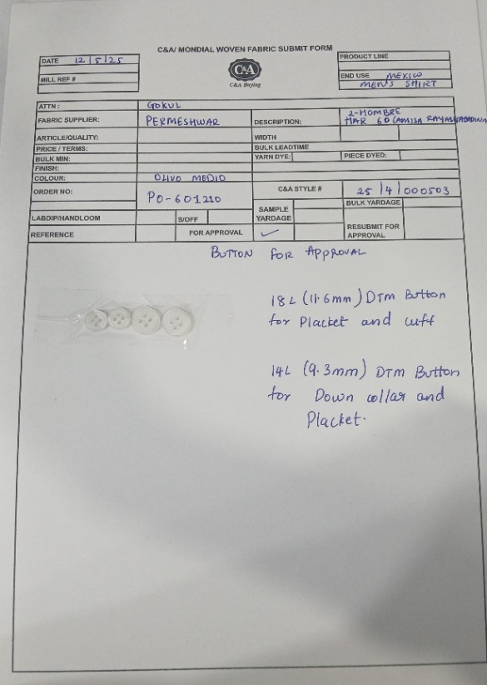

Trim card

Another important task I assisted with was updating order-related Excel sheets. The company maintained a digital tracker for all orders that included key details like style number, buyer name, fabric in/out status, trim approvals, sampling stage, and estimated dispatch date. My mentor explained that this sheet must be updated every day based on new developments. I was given access to a few entries where I could enter updates based on the communication I was handling. This gave me real-time experience in handling production tracking systems.

I also learned a few Excel functions that made tracking easier — such as filters, conditional formatting (to highlight delays), and sorting data by style or buyer. Though this seemed like a routine task, I understood its value in managing multiple styles at once. Without proper documentation, even a single missing update can lead to incorrect production planning. For instance, if a sample is assumed to be dispatched but hasn't left the warehouse, production can get delayed. Hence, keeping the order sheet updated is crucial to smooth operations.

One of the most hands-on tasks I worked on this week was the preparation of tag cards for fit samples and development samples. Every garment sample sent to the buyer must carry a tag card that includes details like style number, buyer code, size, sample type (fit/development/PP), fabric details, and submission date. I was responsible for writing and attaching these tag cards to the garments before dispatch. In some cases, I was also allowed to type the content and take prints.

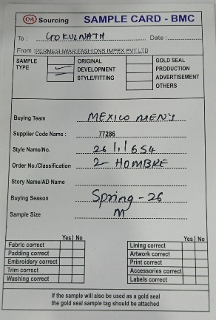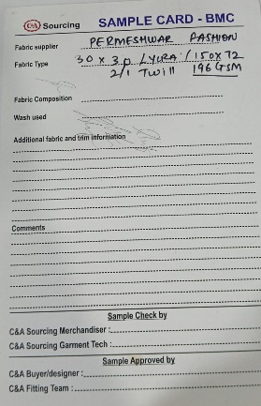

This task helped me realize how even small things like labels and tags carry a lot of importance. If the tag card is missing or incorrect, the buyer might not be able to identify the sample properly, leading to confusion or delays in approvals. I also learned the difference between different types of samples — for example, fit samples are meant for checking the size, construction, and fitting, while development samples are used to evaluate fabric, trims, and design accuracy. Each sample serves a unique purpose and must be documented accordingly.

Apart from these practical tasks, I got the chance to attend a few internal meetings where the merchandisers reviewed the status of current orders. These meetings usually happened at the start or end of the day and helped the team keep track of pending approvals, late fabric arrivals, or any issues raised by buyers. I was asked to take notes during these meetings, and later use the information to update the status sheets or draft reminder emails. This gave me a sense of responsibility and helped improve my listening and documentation skills.

I also noticed how important teamwork is in the merchandising department. No task is done in isolation. For example, to create a trim card, I had to coordinate with the sampling department to get the correct trims, with the documentation team for style codes, and with the warehouse to check the stock. Everyone’s input is needed to complete even a single activity. This taught me the importance of being respectful and cooperative in a work environment, and the need to follow up politely without being pushy.

In between tasks, I also got a better understanding of the different buyer profiles that the company handles. Some buyers focused on basic menswear styles with simple trims and fabrics, while others preferred heavily embellished designs. Each buyer had a specific format for sample submissions, tag cards, and trim approvals. My mentor explained that a good merchandiser must study the buyer’s profile and preferences carefully and ensure that submissions meet their expectations.

By the end of the second week, I felt more confident in communicating with vendors and maintaining documentation. I was still working under supervision, but I was given more independence in handling small tasks. I realized that in merchandising, being proactive is very important. Instead of waiting for someone to tell you what to do, it’s better to ask for pending tasks or look at the order sheet and identify where follow-ups are needed.

I also improved my typing and formatting skills during this week, as I had to prepare documents, tag cards, and email drafts regularly. I understood that even though these are basic skills, they make a big difference in how professional and efficient you appear. Neatly prepared documents and well-structured emails leave a good impression on buyers and suppliers.

One challenge I faced this week was keeping track of multiple styles at the same time. Initially, I was confused between style codes and buyer names, but with the help of reference sheets and a few tricks taught by my mentor, I started managing better. I started maintaining my own notes and to-do lists to ensure I didn’t miss any follow-ups or deadlines.

**Week 2 Conclusion**

To summarize, Week 2 gave me hands-on exposure to how merchandisers maintain smooth coordination between the supplier and buyer. I learned that timely follow-up, accurate documentation, and proper communication are key skills that every merchandiser must develop. I also gained practical experience in preparing trim cards, tag cards, and updating production sheets. These are the behind-the-scenes activities that make a huge difference in the success of a garment order. The experience made me realize how responsible and detail-oriented a merchandiser needs to be. It also helped me develop more confidence in handling professional communication and teamwork.

**Week 3**

**(8th May – 14th May)**

As my internship at Permeshwar Fashion Impex progressed into its third week, I was assigned more responsibilities and gained deeper insight into the sample inspection process, inter-departmental coordination, and garment dispatch activities. This week focused on ensuring that the product being sent to buyers was accurate, well-finished, and matched the required specifications. I also learned about the CMT (Cut, Make, and Trim) process, which forms the backbone of garment manufacturing. This week helped me understand the importance of quality control and how every garment undergoes a thorough checking process before being sent out for approval or final production.

At the start of the week, I was introduced to the process of reading buyer emails carefully and coordinating with various departments based on the requirements mentioned. Buyers often send detailed comments regarding samples — such as size changes, measurement corrections, fabric feedback, or even small styling updates. My role was to go through such emails under the guidance of a senior merchandiser, and then ensure that the points were understood and shared with the sampling or production teams.

This task required me to be very careful with reading and interpreting the emails. Some buyers used technical terms or abbreviations which I noted down and researched. I realized that even one missed point from an email could lead to incorrect sample development. For instance, one of the buyers had written that the shoulder measurement needed a reduction by 0.5 cm in size M. If not read and implemented, the sample could be rejected. This taught me the importance of being detail-oriented.

After understanding the buyer’s comments, I had to follow up with the sampling team to ensure that the required corrections were being made. Sometimes, there was a need to follow up with the pattern master or even the stitching unit if there were technical concerns. In these situations, I acted as a support to the senior merchandisers by checking the progress and updating them regularly. I learned that in merchandising, proper follow-up is not about micromanaging but about ensuring that every department is aligned with the timelines and expectations.

One of the most important activities I performed this week was sample inspection. Every sample, before being dispatched to the buyer, must be thoroughly checked for quality, accuracy, and finish. I was trained to inspect the following:

**Trim Placement:** Checking whether buttons, zippers, lace, drawstrings, and other accessories were placed correctly and securely.

**Measurement Accuracy:** Comparing the sample with the spec sheet to ensure that chest, waist, hip, length, sleeve, and shoulder measurements were within the accepted tolerance.

**Tag Placement:** Ensuring that all sample tags were attached properly with the correct style number, size, fabric information, and sample type.

**Fabric and Stitching Quality:** Checking for fabric defects such as holes, stains, or misprints, and ensuring the stitching was clean and aligned.

I used a measurement tape and printed spec sheet for this task. One of the key things I learned was about tolerance levels — for example, a +/– 1 cm variation in garment length might be acceptable, but anything beyond that may lead to rejection. I also learned how to measure garments in a standardized way — like measuring shoulder seam to shoulder seam, or from HPS (High Point Shoulder) to hem for length.

Sample checking is a time-consuming task and requires a lot of focus. I inspected garments on a checking table, making sure the garment was flat and aligned properly. For each sample, I maintained a checklist and reported the inspection results to my mentor. If there were any major faults, the sample was returned to the sampling department for rework.

Apart from the visual and measurement checks, I also participated in checking for trims and fastener strength. For example, buttons were tested by pulling lightly to see if they were stitched securely. Zippers were checked for smooth function, and drawstrings were examined for clean ends and knotting. All these small details are part of buyer expectations and can impact the final approval decision.

In some cases, I was asked to help in attaching the final tag cards to the samples. These cards included the buyer name, style code, sample type (such as development, fit, or PP), size, and dispatch date. Each tag had to be clean, typed or neatly handwritten, and securely pinned or sewn onto the sample without damaging the fabric. I also assisted in folding the garments neatly and packing them in transparent polybags with clear labelling. Proper packaging makes a good impression on the buyer and reduces confusion.

After the samples were packed, the next step was dispatching them to buyers or buying agents. I was involved in maintaining a sample dispatch register, which included details such as dispatch date, buyer name, courier tracking number, number of pieces, and sample type. For each dispatch, we also had to prepare a challan (dispatch document) which mentioned the same details and was sent along with the parcel. I helped in typing and printing these challans and sticking the courier labels on the parcels.

Once the parcel was dispatched, I had to track the courier status using the tracking number provided by the logistics partner. The moment the parcel was delivered, we had to email the buyer informing them of the delivery and attach a soft copy of the challan. I learned that this step is very important to avoid any confusion regarding parcel delivery and maintain professional communication. Buyers often work with multiple vendors and need proper records to keep track of which sample came from which supplier.

One of the most informative parts of this week was my introduction to the CMT (Cut, Make, and Trim) process. My mentor explained that CMT is one of the most commonly used production methods in the garment industry. In a CMT setup, the buyer usually provides the design, tech pack, and even fabrics and trims in some cases. The manufacturer (or factory) is responsible for three main tasks:

**Cut:** Cutting the fabric accurately according to the marker (pattern layout).

**Make:** Stitching the garment using the correct construction method.

**Trim:** Adding the final elements like buttons, threads trimming, finishing, pressing, and packing

I learned that in CMT-based production, the manufacturer earns money based on the cost of labour and services provided, not the cost of raw materials. Therefore, CMT pricing is very competitive, and the merchandiser has to calculate costs based on labour time, complexity of the garment, and number of operations involved.

Although I was not directly involved in stitching this week, I observed how garments are moved from cutting to stitching to finishing. I visited the cutting room where the fabric was spread on cutting tables and cut as per the marker sheets. I saw the marker printouts and learned how fabric wastage is minimized during cutting. Later, I visited the stitching section where semi-finished garments were being made. Each tailor had a different operation — such as stitching sleeves, attaching collars, or finishing hems.

By observing this workflow, I understood that CMT is a highly organized process, and every small mistake can delay production or increase costs. For example, if cutting is not done properly, entire rolls of fabric can go to waste. Or if the trims are missing during stitching, rework becomes necessary. This made me appreciate the role of the merchandiser in ensuring that the right materials reach the right department at the right time.

Another important concept I learned was quality control during CMT. At every stage — whether cutting, stitching, or trimming — there is a quality checker who ensures that the garment meets the required standards. If a mistake is found, the piece is either corrected or rejected. I realized how the merchandiser must maintain a balance between speed and quality — ensuring timely production without compromising on buyer standards.

**Week 3 Conclusion:**

By the end of Week 3, I felt more confident in my ability to inspect samples, coordinate dispatches, and understand how the CMT system operates. I learned that the merchandising team is responsible for bridging the buyer’s vision and the factory’s execution. This week taught me that small errors in quality, measurement, or packaging can affect buyer trust and future orders. Hence, attention to detail, organized planning, and quality awareness are essential skills for every merchandiser.

**Week 4**

**(15th May – 21st May)**

In the fourth week of my internship at Permeshwar Fashion Impex, I was exposed to more technical and documentation-related aspects of the merchandising workflow. This week primarily focused on understanding and handling tech packs, sampling charts, and fabric sourcing activities. I also learned how to prepare and manage challans for courier shipments, how to communicate with fabric suppliers for pricing and availability, and how to document important fabric details such as GSM and fabric construction. The tasks this week were more technical in nature, which helped me realize how critical attention to detail and systematic documentation are in fashion merchandising.

The week started with an introduction to tech packs, which are comprehensive documents prepared by the buyer and shared with the supplier or manufacturer. These documents act as the blueprint of a garment and include every possible detail required to create an accurate sample. A tech pack typically contains flat sketches, fabric and trim specifications, colourways, artwork placement, size charts, construction details, and sometimes even packaging instructions.

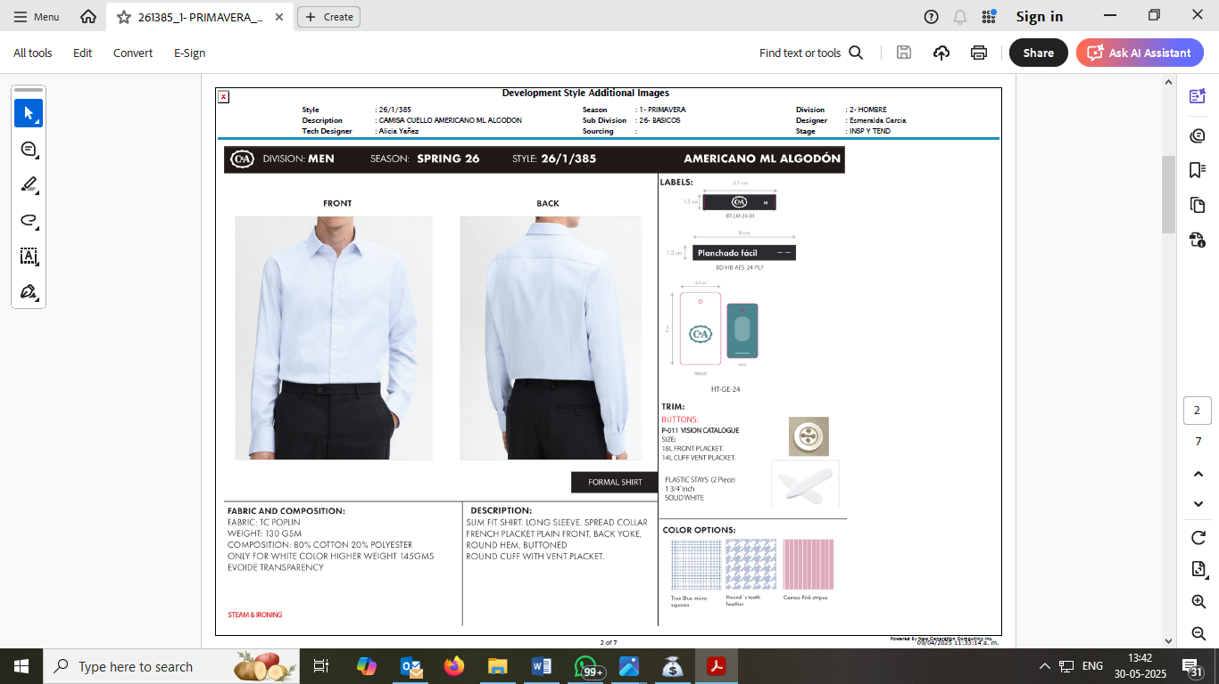

My mentor explained that a merchandiser must be thoroughly familiar with reading and interpreting a tech pack. Before any sample is made, the merchandiser must check the tech pack line by line and ensure that every requirement is communicated to the right department — whether it's the sampling team, pattern master, or fabric sourcing unit. I was given a few real tech packs to study and cross-check with existing samples. This helped me develop an understanding of how each technical detail translates into a real garment.

I also learned how to compare the measurement chart in the tech pack with the actual garment to ensure consistency. Sometimes, the buyer shares updates or corrections to the tech pack over email, and it is the merchandiser’s job to keep all versions updated and documented. I helped in printing, organizing, and attaching updated tech packs to style folders. These folders serve as references during sampling, production, and quality control.

In addition to tech packs, I was assigned the task of updating the sampling chart maintained by the company. A sampling chart is an internal document that tracks the status of all samples being developed at any given time. It includes details like:

Buyer Name

Style Number

Sample Type (Fit/Development/PP/Size Set)

Date of Request

Tech Pack Received (Yes/No)

Fabric/Trims Sourced (Yes/No)

Sampling Status (In Progress/Completed/Dispatched)

Buyer Approval (Pending/Approved/Rejected)

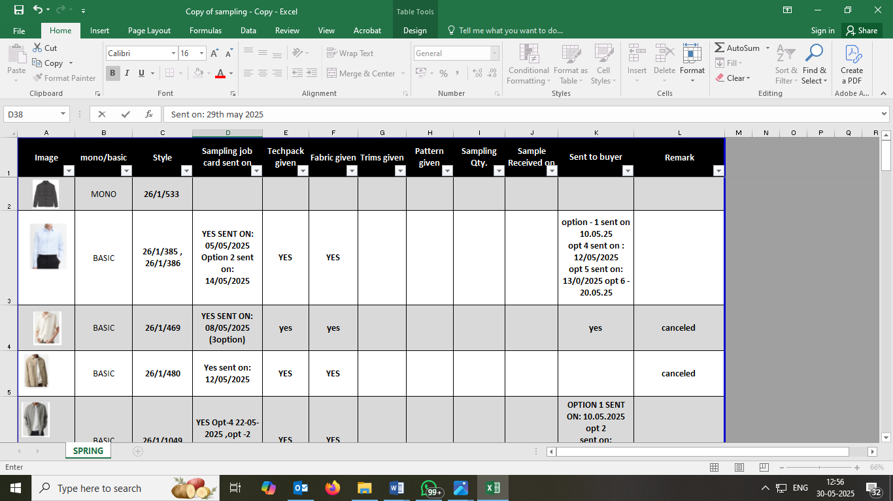

My task was to update this chart based on the latest progress in sampling. For example, if a fabric was received or if a sample was dispatched, the corresponding cell had to be updated. This chart helped the entire merchandising team keep track of pending tasks and deadlines. I was trained to use Excel filters and colour codes to highlight urgent samples or rejected styles. This task, though administrative, helped me develop a more organized and professional approach to data management.

One of the most interesting parts of the week was learning about fabric sourcing. In fashion merchandising, sourcing plays a key role in ensuring that the right fabric is selected based on buyer preferences, garment requirements, and budget constraints. I was introduced to the company’s supplier database and shown how to contact vendors for fabric swatches, pricing, and minimum order quantity (MOQ).

Under supervision, I sent out email inquiries to fabric suppliers for a few styles in development. Each email needed to include details like the fabric type (e.g., cotton twill, rayon slub), desired GSM range, width, color reference (if any), and target price. I learned to attach an image or buyer reference where applicable and request the supplier to send physical swatches. This experience helped me build confidence in professional communication and taught me the correct way to draft concise but informative sourcing emails.

When fabric swatches arrived from vendors, I was given the responsibility of collecting and cutting A4-sized swatches to be used for internal references and buyer submissions. These swatches were labelled with fabric name, composition, GSM, supplier name, and date received. I also had to paste them onto swatch cards and maintain a separate swatch file for each buyer. I found this activity both creative and technical, as it involved presentation as well as attention to specification details.

An important technical concept I learned in college was GSM (Grams per Square Meter). It is a standard unit used to measure the weight of fabric, and it directly affects the drape, feel, and thickness of the final garment. I was taught how to measure GSM using a GSM cutter and digital weighing scale. So I used that in my practical life of Internship.

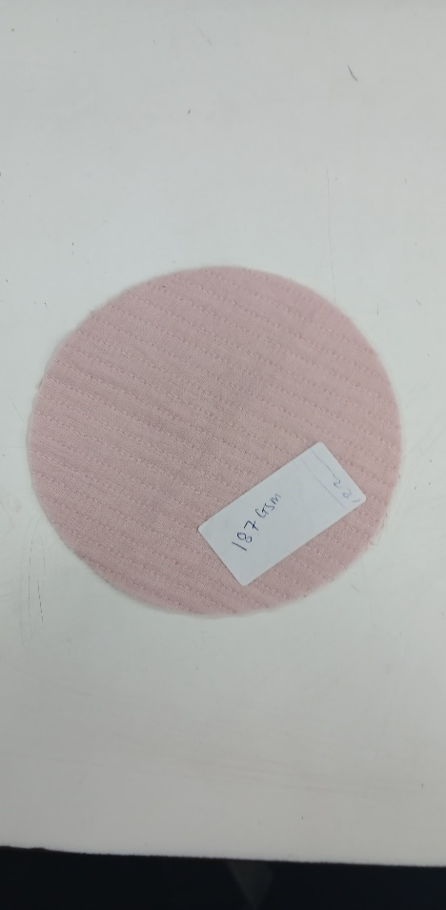

In addition to sourcing swatches, I was asked to request bulk fabric prices and MOQ from suppliers. This meant that beyond sampling, I was also beginning to understand bulk planning and cost estimation. I sent follow-up emails asking vendors to quote the price per meter for large quantities (for example, 1000 meters) and share lead times for delivery. Sometimes, suppliers also offered alternative qualities or finishes, and I had to record all this data in a comparative sheet. This helped the senior merchandisers decide which supplier to finalize for production.

Another key learning this week was how to prepare a challan for courier shipments. A challan is a formal document that acts as a proof of dispatch and includes all shipment details. It usually lists the items being sent, their quantity, purpose (e.g., fit sample, lab dip, and fabric swatch), courier name, and tracking number. I helped prepare challans using company`s MIS software and also entered the dispatch records in the company’s shipment register. Some shipments were sent to buyers, while others were sent to factories or suppliers. Each type of dispatch needed to be documented properly.

Challans not only serve as internal records but also help avoid disputes or confusion regarding delivery. For example, if a buyer claims they did not receive a sample, the merchandiser can use the courier challan and tracking number to verify the delivery. I also learned to attach soft copies of the challans to follow-up emails sent after dispatch. This practice is essential to maintain transparency and build professional trust.

This week also taught me the importance of speed and responsiveness in merchandising. For instance, if a buyer asks for an urgent fabric option or price quote, it must be arranged and shared within 24 hours. Delays can lead to losing a style or missing production slots. I realized that even though sourcing, sampling, and documentation are technical tasks, they must be performed with a sense of urgency and discipline. My mentor often reminded me, “Merchandising is all about timelines — if you're even a day late, it affects the whole chain.”

Another useful practice I observed was maintaining digital backups of all files and swatch photos. Every swatch received from vendors was not only filed physically but also photographed and stored in shared folders categorized by buyer name and style number. This helped in quick sharing with buyers when required and reduced the risk of losing physical samples.

Towards the end of the week, I attended a brief session with the fabric testing team, where they explained how basic fabric testing is done for shrinkage, colourfastness’, and pilling. Although I didn’t perform these tests myself, I understood how fabric performance is evaluated before finalizing bulk orders. The merchandiser has to ensure that the selected fabric meets the buyer's technical requirements and doesn’t lead to complaints later.

**Week 4 Conclusion:**

In summary, Week 4 of my internship was extremely valuable in building my understanding of the technical side of merchandising. I learned how to read and manage tech packs, update sampling charts with accuracy, and handle the process of fabric sourcing from start to finish. I gained exposure to fabric properties like GSM and construction, and understood the importance of precise documentation through challans and sampling charts. I also developed practical skills in swatch preparation, professional emailing, and basic quality evaluation. This week gave me the confidence to handle sourcing tasks independently and made me realize the importance of combining creativity with technical accuracy in the field of fashion merchandising.

**WEEK 5**

**(22nd May – 28th May)**

During the fifth week of my internship at Permeshwar Fashion Impex, I was introduced to the digital tools and documentation practices used in the merchandising department. The week focused on training related to software applications and documentation tools used for tracking samples, communicating with buyers, and coordinating production activities. I also got the chance to work on embellishment coordination and assist in preparing fabric and embroidery-related documents. It was a crucial learning period that taught me how digital processes help a merchandiser manage multiple tasks in a systematic and efficient way.

One of the primary tools used at the company was the PLM software. PLM is a centralized platform that stores all product-related information, such as tech packs, sample status, buyer comments, and timelines. I was guided through the software by my mentor and shown how different departments input information so that all stakeholders can stay updated. For example, I learned how to check whether a development sample had been sent, whether a fit sample was approved, or if any changes had been requested by the buyer.

I also learned how to upload small pieces of information under supervision, such as style numbers, dispatch dates, and reference images. This gave me a better understanding of the workflow and made me realize how important it is to enter data carefully and consistently. Each style had a unique code, and one small error in this code could cause confusion later. PLM made it easy to trace sample progress, identify delays, and refer back to buyer comments, all in one place.

Along with PLM, I regularly used Excel sheets to update sampling records and maintain internal trackers. Although PLM stores master data, Excel is commonly used for day-to-day tracking, reports, and quick updates. I worked on updating an Excel-based sample tracker that listed details like buyer name, style number, fabric details, sample sent dates, and pending approvals. I also created a simple summary of "styles waiting for buyer approval" based on the email follow-ups from Outlook. These Excel files helped senior merchandisers plan their priorities and stay informed about the current status of multiple orders.

Another software tool I used daily was Outlook, which is used for formal communication within the company and with external parties such as buyers and suppliers. I was allowed to draft professional emails under supervision. These included follow-ups regarding sample approvals, embroidery placements, fabric sourcing, and sample dispatch confirmations. I learned to keep email content clear, concise, and well-formatted. Each email had to include essential information like the style number, buyer name, and correct attachments.

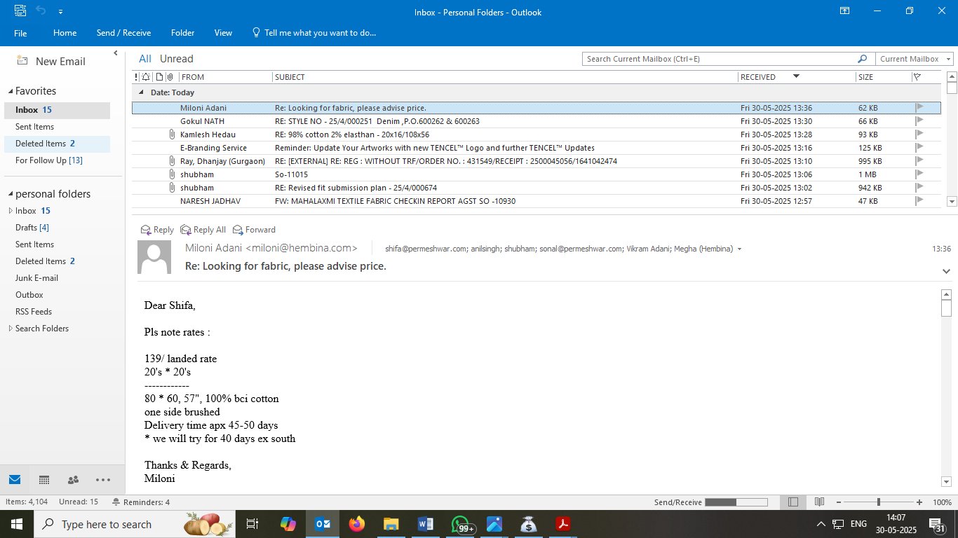

One of the key tasks I was involved in was sending placement queries to buyers regarding embroidery belts and other embellished parts of the garment. Embellishments such as sequins, beads, and embroidery motifs need to be placed accurately on the garment to meet the buyer’s design expectations. However, buyer-provided references were sometimes unclear or open to interpretation. In such cases, the merchandising team sends a placement query asking for confirmation on exact positions, dimensions, or instructions.

I assisted in preparing these queries using PowerPoint and image editing tools. We marked placement references using arrows and callouts to highlight our doubts, and then we saved the file with a clear name (e.g., "BuyerName_StyleCode_EmbPlacementQuery.pdf"). These visuals were then emailed to the buyer using Outlook, accompanied by a polite request for clarification. This process helped prevent misunderstandings that could delay approvals or result in incorrect sample development.

In addition to communication, I was trained in preparing important production-related documents. One such document was the job card, which acts as a guiding document for the production team. A job card includes details such as the style number, buyer name, sample size, fabric type, trims required, and any special instructions. I helped fill out job card templates for styles that had cleared initial approval and were ready for development or pre-production sampling.

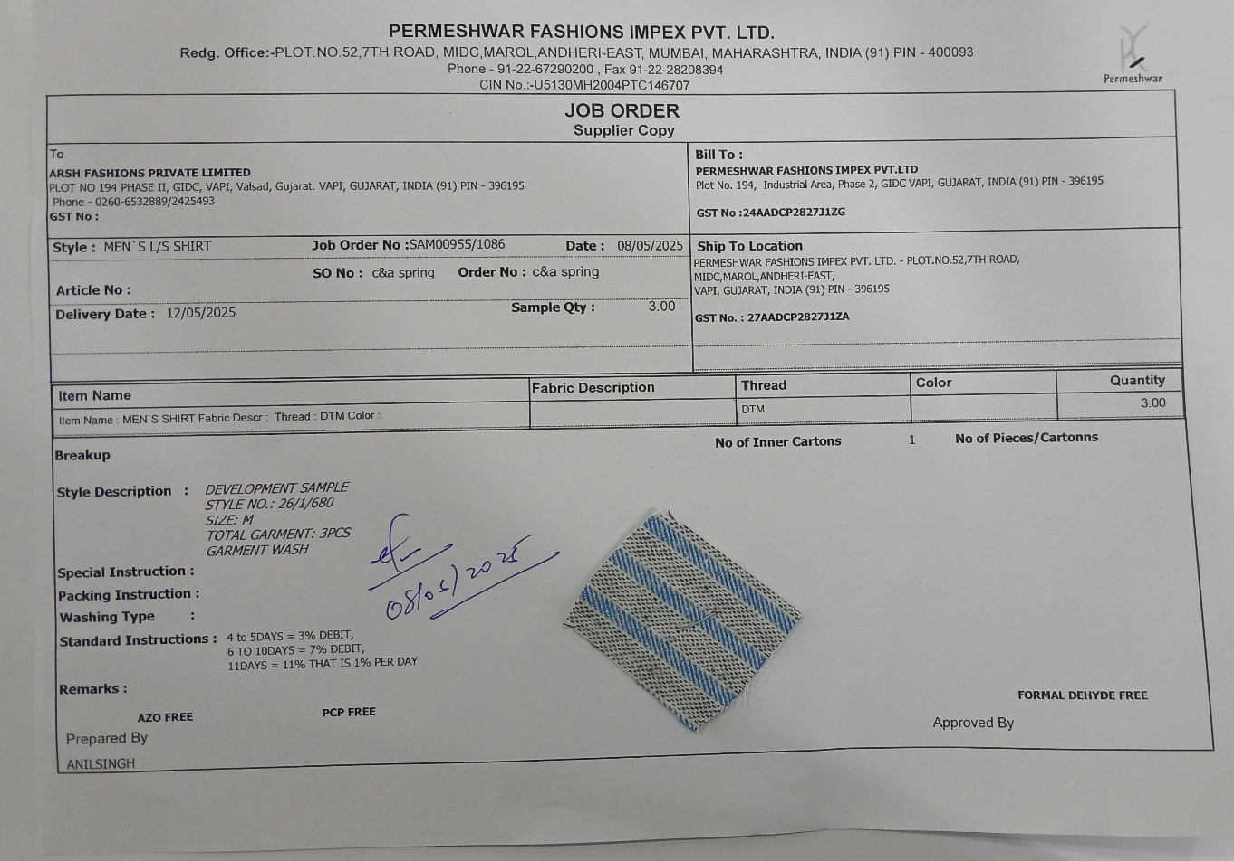

JOB CARD

I also assisted in preparing fabric sample purchase orders (P.O.), which are sent to suppliers when a small amount of fabric is needed for development samples. These P.O.s included details like fabric type, supplier name, rate per meter, required quantity, and delivery deadline. These documents are essential to ensure that the right material reaches the sampling unit on time. Preparing these P.O.s gave me insight into vendor communication, order formats, and how even a small sample order is managed professionally.

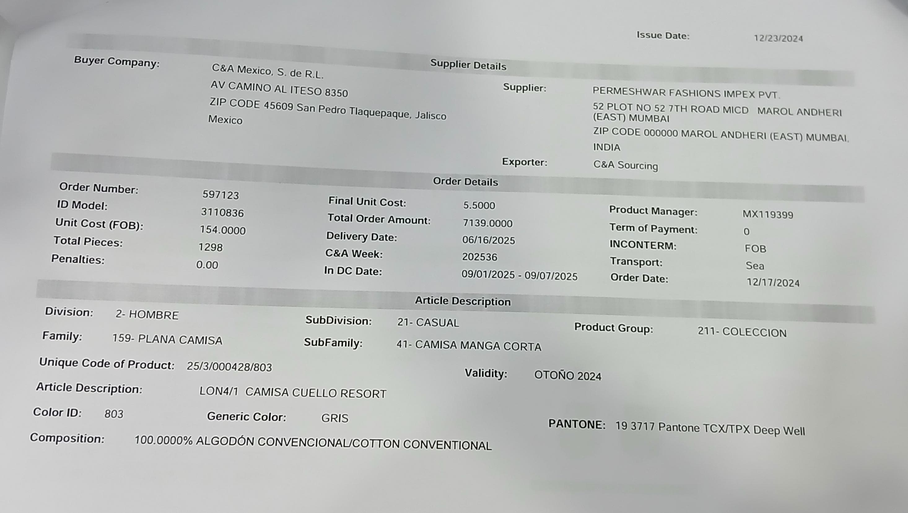

P.O

Another new skill I learned this week was the generation of computerized challans for courier shipments. A challan is a document that accompanies physical samples when they are dispatched to the buyer or head office. It includes details like the contents of the parcel, the style numbers, sample type, courier name, and docket number. Earlier, I had prepared Excel-based manual challans, but this week, I was trained to use the company’s official format for computerized challans. These challans were more professional, printed on company letterhead, and had official serial numbers.

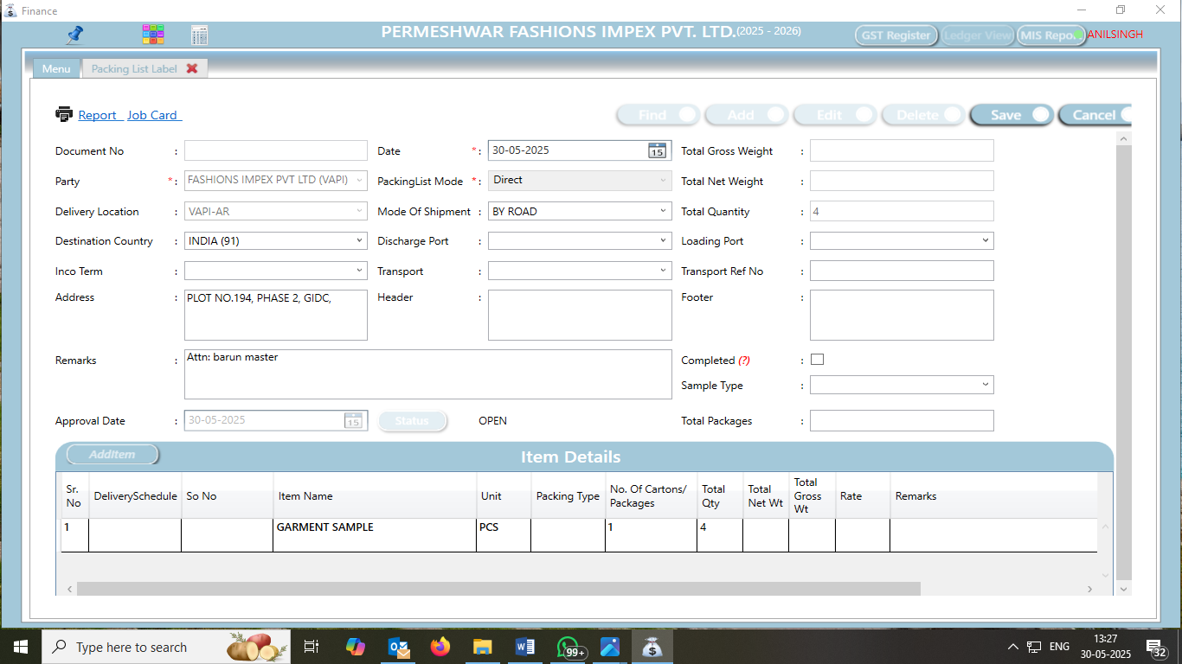

After generating the challan, I ensured it was signed and attached to the parcel before handing it over to the courier. I also scanned a digital copy and emailed it to the buyer through Outlook, along with the courier tracking number. This process ensured proper documentation and accountability for every dispatched sample.

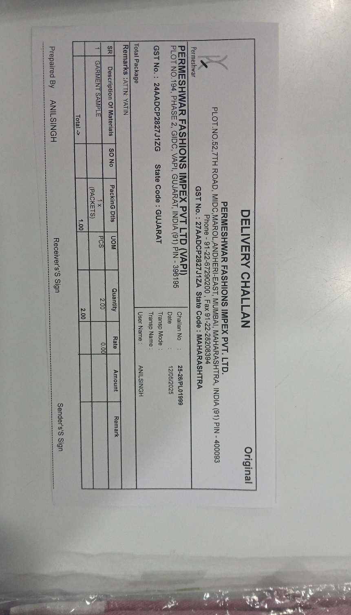

One of the key documents I observed being prepared this week was the OCMS (Order and Cost Management Sheet). It refers to a detailed sheet that is shared with buyers. This sheet includes the full breakdown of costings, style information, production details, and timelines for delivery. I assisted my mentor in reviewing the OCMS for styles before it was sent to the buyer. Although I didn’t prepare the full sheet myself, I helped verify style numbers, trim costs, fabric names, and sample types to ensure the data matched the actual developments.

The OCMS sheet is critical because it acts as a contract or agreement between the buyer and the company. Once the buyer approves it, any changes in costs, materials, or timelines must be renegotiated. Therefore, it must be 100% accurate and up to date. I understood the importance of verifying every entry and ensuring all costs were backed by actual vendor quotations or confirmed rates.

By the end of the week, I realized how central digital tools and documentation are to a merchandiser’s job. Whether it’s PLM for lifecycle tracking, Excel for internal reporting, Outlook for communication, or OCMS for costing agreements, each tool plays a major role in keeping the merchandising process organized. I also gained exposure to how these tools interact with physical tasks such as sampling, embellishment placement, and vendor coordination.

**Week 5 conclusion:**

Overall, Week 5 was a significant turning point in my internship experience. It bridged the gap between manual merchandising work and the digital systems used to manage it. I became more comfortable with professional communication, understood the importance of clear and timely data entry, and realized how crucial proper documentation is at every stage of the merchandising cycle. These skills and observations will help me in my future career, as most companies now rely heavily on digital operations for efficiency and accuracy in the fashion industry.

**WEEK 6**

**(29th May -4th June)**

The sixth and final week of my internship at Permeshwar Fashion Impex focused on two important aspects of fashion merchandising: Costing and Material Requirement Planning (MRP). This week gave me valuable insight into how financial planning and inventory management are handled in a fashion export company. While previous weeks taught me about sampling, sourcing, and coordination, this week helped me understand the business side of merchandising, including how prices are determined and how resources are planned to ensure smooth production and delivery.

The week began with a detailed explanation of the costing process. I learned that costing is not just assigning a price to a garment — it involves calculating the exact cost of every material and activity involved in producing that garment. Under the guidance of the senior merchandisers and costing team, I observed how a cost sheet is prepared once a sample is approved. The process starts with breaking down the garment into its raw materials — such as fabric, buttons, zippers, threads, labels, and packaging items — all listed under the Bill of Materials (BOM).

I assisted in updating Excel-based BOM sheets with the latest prices of trims and fabrics, which were collected from vendor quotations and earlier purchase orders. I also helped in checking standard costs for size labels, main labels, hang tags, and desiccants. Through this, I understood how even small details, like the type of label or quality of polybag, can affect the final garment cost.

The next part of costing involved understanding CMT (Cut-Make-Trim) costs, which refer to the labour cost of producing the garment once raw materials are available. CMT includes charges for cutting, stitching, finishing, and packing. I was shown how these costs vary depending on the complexity of the garment and the level of detailing, such as embroidery or lining. I compared CMT rates for different development styles and learned how previous season references are used to estimate labour costs accurately.

Once the raw material and CMT costs are added, the team calculates the total cost per piece. Additional costs like testing charges, freight, and a buffer for unexpected expenses (usually around 2–3%) are also included. This ensures that the company doesn’t suffer losses if there are last-minute changes or extra charges during production. After finalizing the total cost, the FOB (Free on Board) price is calculated, which includes the company’s profit margin and is offered to the buyer. I observed how the team negotiates this price, sometimes adjusting material choices or trimming costs slightly to match the buyer’s target rate without affecting product quality.

During this week, I also worked more closely with OCMS (Order and Cost Management Sheet) — a detailed sheet shared with buyers that outlines the cost breakdown, BOM, size ratios, delivery schedule, and packaging instructions. My task was to verify OCMS entries for a few new styles. This included checking that fabric details, rates, and item codes matched the internal records. This experience helped me understand how accurate documentation is essential not just internally, but also for maintaining trust and transparency with buyers.

The second major area of focus this week was MRP – Material Requirement Planning. Unlike the earlier weeks where I worked on sourcing and collecting swatches, this time I participated in end-to-end material planning for bulk orders. Once a style is approved and an order is confirmed by the buyer, the merchandising team prepares an MRP plan for all required materials — fabric, trims, labels, and packaging items — based on the order quantity and size ratio.

I helped calculate fabric consumption using garment specs and marker efficiency. Fabric requirement is always rounded up to account for wastage. For trims like labels, tags, and buttons, we calculated quantities based on total order size and size-wise breakdown. I also updated the MRP tracker, which is a planning tool used to monitor required materials, vendor status, delivery dates, and pending P.O.s. This tracker helped the team quickly identify if any item was delayed or missing and take action accordingly.

A key learning this week was how to match material availability with the production timeline. For instance, fabric sourcing usually takes longer than trims, so it must be booked in advance. I supported the team in drafting emails to vendors, requesting updated prices, delivery dates, and MOQ (Minimum Order Quantity). Based on responses, the team issued purchase orders. This planning process plays a big role in avoiding production delays.

I also assisted in preparing trim requirement sheets listing every item needed per style — including trim codes, colour, size, and quantity. These were then shared with approved suppliers. For packaging materials like cartons, polybags, and desiccants, I referred to the buyer’s packaging guidelines and helped match the requirements with available stock.

An important aspect of MRP that I observed was the effort to balance quality with cost. For example, in one case, the team had to choose between two types of size labels — one more affordable and one with a satin finish. They selected the one that aligned with both the buyer’s expectations and the costing margin. Such small decisions help the company maintain quality while staying within budget.

Throughout the week, I could clearly see how all the concepts I had learned earlier like fabric sourcing in Week 2, sample inspections in Week 3, and software use in Week 5 were now coming together in a more structured and goal-driven way. Tasks like verifying OCMS, updating Excel sheets, preparing BOMs, and coordinating with vendors now made more sense as I saw their role in the broader production and business timeline.

**Week 6 Conclusion:**

In conclusion, Week 6 helped me connect the dots across all the stages of merchandising I experienced during the internship. From design development to costing, and from vendor communication to final dispatch, I realized that merchandising is all about coordination, accuracy, and timely decision-making. This week especially gave me a solid foundation in understanding how pricing is set, how budgets are planned, and how raw materials are efficiently managed to ensure smooth and profitable production. It reinforced the fact that merchandising is not just about following up on tasks, but about understanding the complete journey of a garment and ensuring every step adds value. This experience has greatly strengthened my confidence and understanding as I look forward to a future career in fashion merchandising.

**SOFTWARE AND TOOLS USED**

During my internship at PErmeshwar Fashion Impex, I had the chance to work with important software tools used in the merchandising and export industry. These tools helped me complete tasks more efficiently and gave me hands-on experience with real-time digital workflows.

**PLM** – Company Software

The company’s proprietary PLM software was used for managing garment development from sampling to dispatch. I used it to prepare computerized courier challans, generate job cards, and create fabric sample purchase orders. The software helped maintain a clear and systematic workflow and allowed for smooth coordination between teams.

**Microsoft Outlook** – Email Communication

Outlook was used for all professional communication. I sent emails to buyers and suppliers for follow-ups, sample queries, and approvals. I also learned how to organize emails, manage folders, and use features like CC/BCC and calendar scheduling. This helped improve my email etiquette and time management.

**Adobe Acrobat** – PDF Review and Marking

Most documents like tech packs and OCMS sheets were shared in PDF format. Using Adobe Acrobat, I reviewed these files, highlighted key information, and added comments. It helped me understand specifications more clearly and stay updated with buyer instructions.

**Microsoft Excel** – Data Handling

Excel was widely used for cost sheets, BOMs, MRP planning, and order tracking. I learned to use basic formulas, sorting tools, and formatting functions to manage and present merchandising data accurately.

**Microsoft Word** – Documentation

I used Word to prepare trim details, draft internal notes, and create professional documents for buyers. It helped me develop clear and well-structured documentation skills needed in the merchandising workflow.

**CONCLUSION**

My six-week internship at Permeshwar Fashion Impex was a valuable and eye-opening experience that helped me understand the true depth and complexity of fashion merchandising. While I had studied the subject in theory as part of my academic curriculum, this internship allowed me to witness and participate in the actual workings of a professional export house. It helped me connect the dots between classroom learning and practical application, giving me a holistic understanding of the merchandising cycle from design development to final dispatch.

Throughout the internship, I observed how merchandising is not limited to just coordination or communication—it is a multi-layered process that involves planning, analysis, creativity, and technical know-how. I got the opportunity to work on a variety of tasks such as creating lab dips and trim cards, following up with suppliers, updating order sheets, inspecting samples, and participating in costing and MRP planning. Each activity helped me understand a different aspect of merchandising, and together, they gave me a complete picture of the responsibilities handled by a merchandiser.

One of the most important lessons I learned was the importance of communication and coordination. The merchandiser acts as a bridge between the buyer, the suppliers, and the internal teams. Timely follow-ups, clear emails, and regular updates are essential for smooth workflow and meeting deadlines. I also realized how important documentation and accuracy are in this field. From maintaining Excel sheets and OCMS files to verifying trims and measurements, every detail matters and any mistake can lead to serious issues in production or delivery.

Another key learning area for me was the costing and MRP process. Before this internship, I did not realize how much financial planning goes into developing a single garment. I was able to understand how cost sheets are prepared by breaking down material costs, CMT charges, overheads, and profit margins. I also saw how MRP planning ensures that all required materials are ordered and available in the right quantities and timelines to support bulk production. These experiences showed me the business side of fashion and taught me how crucial it is to balance quality, cost, and efficiency.

The use of software like PLM, Excel, and email platforms such as Outlook also helped me become more confident in handling technical tools that are commonly used in the industry. I learned how digital systems support merchandising by keeping track of orders, samples, costs, and shipments.

Overall, this internship allowed me to grow both professionally and personally. It gave me the confidence to take initiative, work in a team, and handle real responsibilities. I now feel more prepared to enter the fashion industry with practical knowledge, clarity of roles, and a deeper interest in the field of merchandising. Most importantly, it helped me connect everything I’ve learned so far and gave me a clear direction for my future career.